Project Methodologies

The method that is going to be used to this project is Waterfall methodology.

The methodology it is a development process that follows a sequential manner that flows like a waterfall through all phases of a project.

These process are:- i) Requirement ii) Design iii) Implementation

iv) Verification and Testing v) Deployment & Maintenance

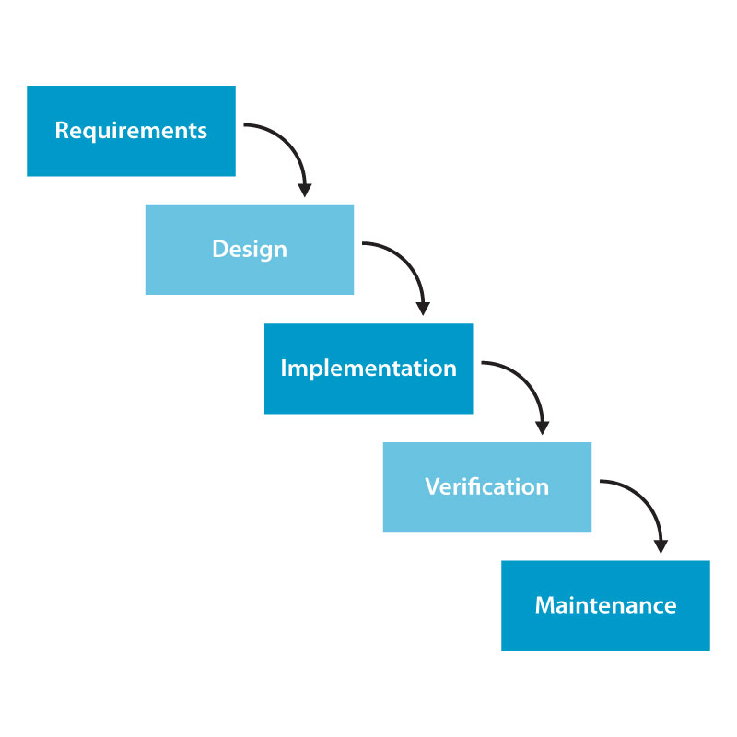

Project Use Case model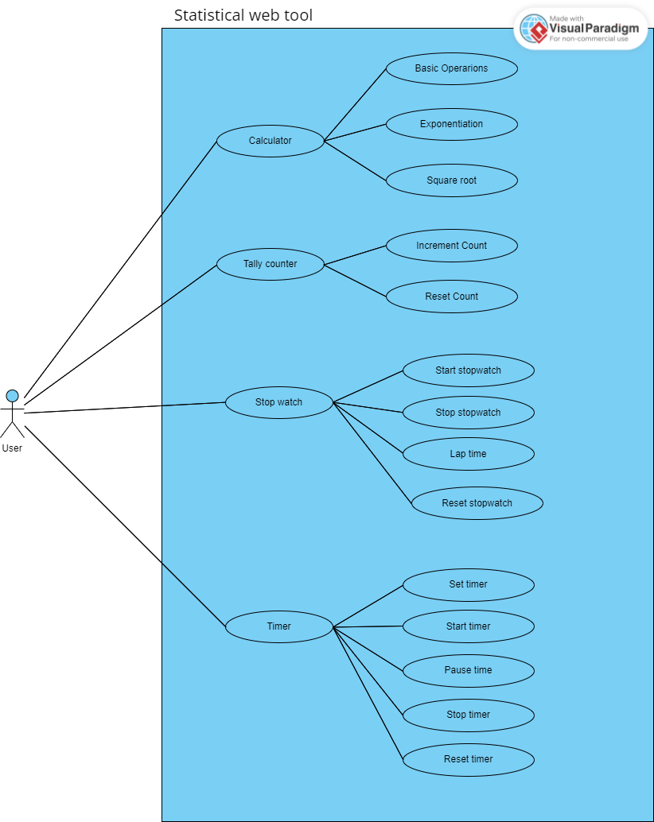

System Modelling

Context model

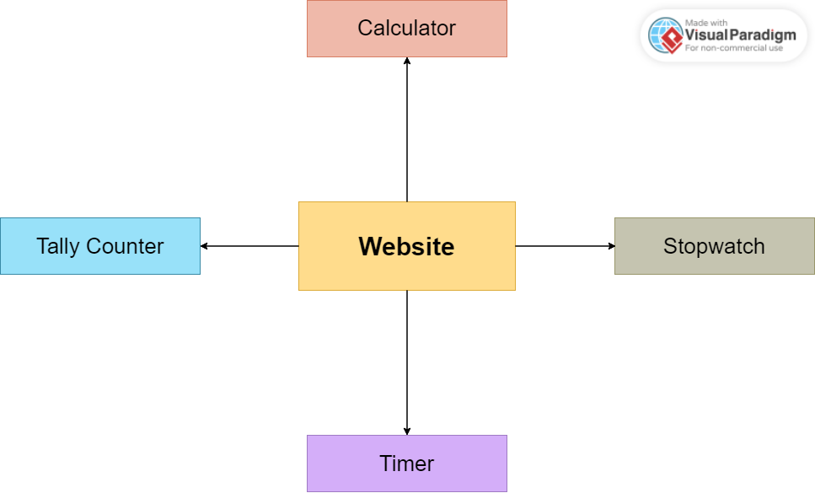

The user interacts with the website which has four features

The added features are represented with the other rectangular boxes.

The arrows show the connection between the website and its features

Interaction model

In the interaction model I am using a sequence diagram displayed below:

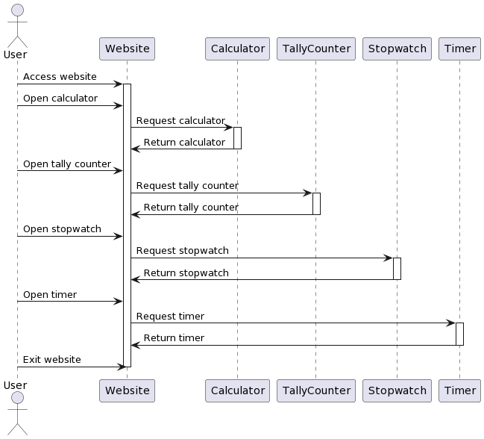

In the above diagram the user can access the website and open various features.

The features are represented by separate participants, the arrows indicate the request between the user and the website or the website and he features

Then the feature respond by returning to the website

Structural models

Class diagram

In the structural model I am using a class diagram displayed below:

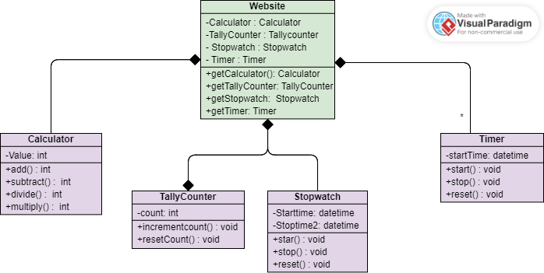

The website is represented by a class in this class diagram that has private variables for the calculator, tally counter, stopwatch, and timer features.

Each feature is represented by a different class that contains methods to carry out its particular tasks.

Each feature is accessible via public methods in the website class; there is no direct relationship between the features.

Behavioral models

Data flow diagram

In the behavioral model I am using a data flow diagram displayed below:

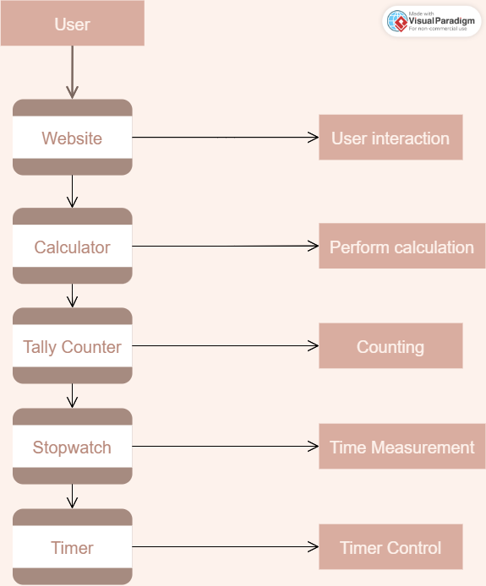

In this DFD, the website is represented as the main process that interacts with the user. The website process sends and receives data to and from the four sub-processes: Calculator, Tally Counter, Stopwatch, and Timer.

The Calculator sub-process performs calculations and sends the results back to the website process.

The Tally Counter sub-process counts the number of times a certain action is performed and sends the count back to the website process.

The Stopwatch sub-process measures time elapsed and sends the elapsed time back to the website process.

The Timer sub-process controls the duration of time and sends notifications to the website process when the time is up.